**Teach Easy**

**Bits Please!**

**User Manual**

**Last Update: 12/02/2018**

**Introduction**

Teach Easy is the solution to the everyday problems faced by teachers across West Virginia. Our software is being developed out of necessity and requests from teachers in the state that are dissatisfied with their current software. Not only have our stakeholders complained about the usability of their current software, but the state is paying huge sums of money for these unusable softwares. Our company is non-profit, allowing Teach Easy to be a cost efficient solution.

This idea originally came from a teacher who is currently very dissatisfied with their software that is being provided to them. We have heard complaints of small text boxes, highly limited options, and overall hard to use software. Teach Easy aims to provide the highest quality service possible for our clients and we enjoy getting feedback from our users so that we can improve and make them even happier with our company, software, and their experience.

What does Teach Easy do? We solve all of our users problems. We are creating an easy one-stop-shop way to keep your schedule, notes, grades, and even state mandated lesson plans all in the same account. The administration will have an easy way to show the state what their teachers are doing and they’ll have records of what was done. Each teacher’s lesson plans will be in the same, easily readable format, which is great for quickly finding information in each school for the state administrators.

**Table of Contents**

**1.1.0 Glossary**

**2.1.0 Contributors**

**3.1.0 Featured Pages**

**3.1.1 Login**

**3.1.2 Interface**

**3.1.3 Credentials**

**3.1.4 Logout**

**3.2.1 Calendar**

**3.2.2 View Events**

**3.2.3 Add Events**

**3.2.4 Edit Events**

**3.2.5 Delete Events**

**3.2.6 View Lesson Plans**

**3.2.7 Edit Lesson Plans**

**3.3.1 Attendance**

**3.3.2 Display Current Absences**

**3.3.3 Take Attendance**

**3.3.4 Add Single Absence**

**3.3.5 Remove Absence**

**3.4.1 Gradebook**

**3.4.2 Subjects**

**3.4.3 Students**

**3.4.4 Grade Entry**

**1.1.0 Glossary**

***Header*** - the top of a page that is consistent across pages

***Integer*** - a number with no decimal

***Field*** - a point of data entry; usually represented at a textbox, radio button or checkbox

***Modal*** - an overlay of the page that pops up

**2.1.0 Contributors**

Lauren Cox

Kylie Kent

Makayla Ballenger

Bri Cochran

Matt Strand

**3.1.0 Featured Pages**

**3.1.1 Login**

The Login page is the first page you will come to when entering the correct URL.

**3.1.2 Interface**

Our interface for the login page is fairly simple. It features a chalkboard background with the Teach Easy logo in the upper left corner and a login area in the middle of the screen with a two boxes where you enter the username and password.

**3.1.3 Credentials**

As a teacher, you will be provided your username and password combination. You must use the exact login information we give you and place the username in the first box and the password in the second box. The password will be hidden when you type it.



**3.1.4 Logout**

After having been signed in to our software, at the top right hand corner you will be able to see your full name and right below your name, there is “Log Out” in red text. Click this when you are ready to sign out of the program.

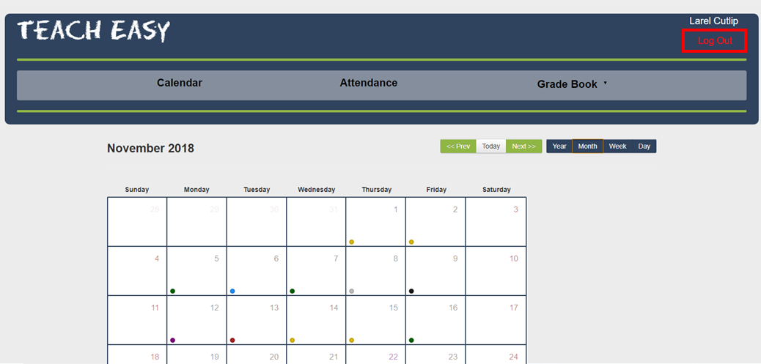

**3.2.1 Calendar**

The calendar is the main hub of our software. This is where you will be able to view the entire semester in a calendar format. Events consists of notes and lesson plans and will be displayed on the days which they corresponds with. The calendar can change views from a specific day, to a week,then the month, and lastly to see the entire year.

**3.2.2 View Events**

Events can be viewed in many different ways.

**Month View**

Hovering over a dot in the month view will show you the title of the event. You can also click on the day itself and a drop down box will appear showing the title as well. Clicking on the title in the drop down box will redirect you to a page to view the event in more detail. If you click on the dot that you can hover over you will be redirected to a page to view the event as well.

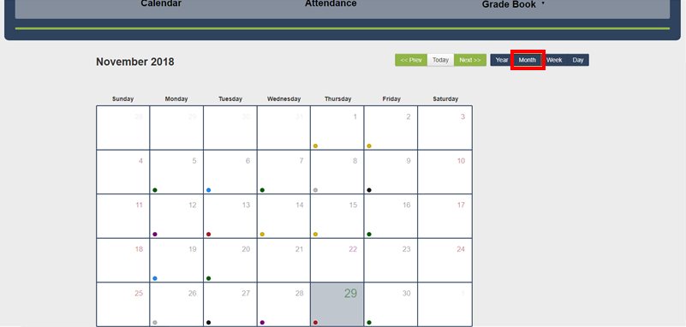

**Year View**

In the year view clicking on a month will create a drop down box where you can view all the event titles of that month and their respective corresponding color they appear in. Clicking on any of the event titles will redirect you to a page for that specific event to view. 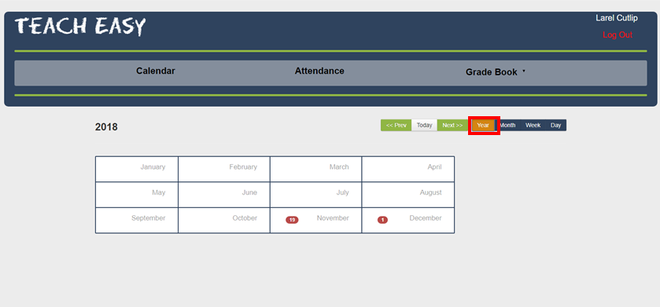

**Week View**

In week view a week is displayed and each title for any events that week are displayed. Clicking on any title will redirect you to the page to view the event in more detail.

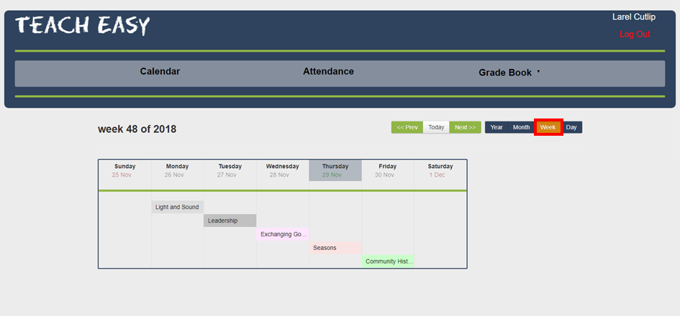

**Day View**

In day view events are displayed by the times the events are active with the title of the event for that specific day. Clicking on the title will redirect you to the page to view the event in more detail.

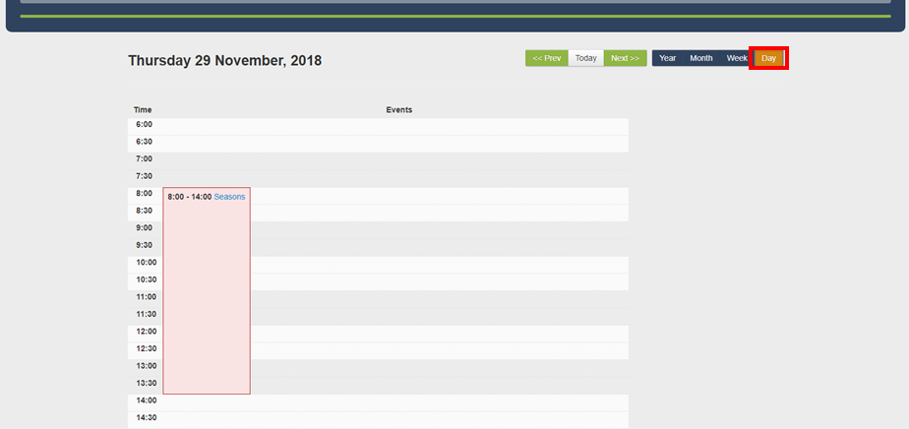

**3.2.3 Add Events**

To add an event you will need to navigate to the event.json.php file in the main group of files. In this file each event is manually added. Each event has an Id,Title,Class,Url,Start,and End tag. Every event will need each of these tags, but the Url and a specific Class tag to function properly.

**ID**

The Id tag is the same number as the id that appears in the database to avoid confusion. Giving events the same Id will result in an error so make sure each event has a unique Id.

**Title**

The title tag is where the title of the event goes. This title tag will be displayed wherever the even title appears in the website.

**Class**

The class tag determines the color of the event dot and the shade it will appear in the different views. The class tag was originally made to display different event types, but their is not physical difference between them just color. If you want to change the name of the classes you will have to refer to the calendar.php file. Leaving out a specific class tag will default the color to gray.

**URL**

The url tag is for the url that redirects you to the view events page. You can leave out the url if you want the events to not redirect to another page.

**Start**

The start tag is the time and date the event starts on in milliseconds. You will need to convert the time and date yourself in milliseconds either with a program or an online tool.

**End**

The end tag is the same as the start tag it's just the end time and date of the event.

**3.2.4 Edit Events**

To edit an event you will need to navigate to the event.json.php file. Once there you can manually edit any of the tags to your liking. Refer to how to add events above for descriptions of the tags.

**3.2.5 Delete Events**

To delete an event you simply delete all related tags to said event. Be careful of the open and closing brackets that surround each event. Those will also have to be deleted. Each event is separated by a common in the file as well.

**3.2.6 View Lesson Plans**

Clicking on an event link will take you to the page for a lesson plan. On this page you can view the details of the lesson plan. Using the navigation bar at the top of the page will take you back to the calendar.

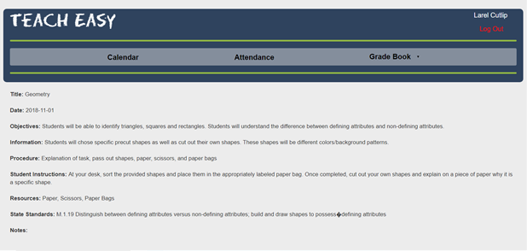

**3.2.7 Edit Lesson Plans**

To edit the lesson plan navigate to the lessonPlans.php file in the list of files for this project. The lesson plan is connected through the database. To change the lesson plan, set the id in the sql statement to the id of the desired lesson plan.

**3.3.1 Attendance**

The home attendance page displays each student and how many absences each, then gives a list of each date they were absent.

**3.3.2 Display Current Absences**

Current absences can always be obtained from a logged in user by clicking the button in the navigation bar on the top of the screen labeled “Attendance”. Attendance can also be reopened from the “Take Attendance” Screen via the button labeled “Check Absences”.

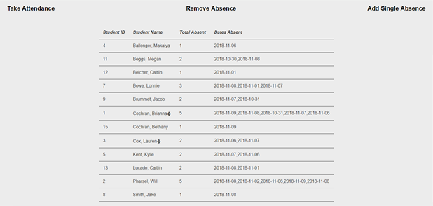

**3.3.3 Take Attendance**

Taking Attendance can be done in two ways. The first is by clicking “Take Attendance” from the “Attendance” page. This will bring up a page with the user’s assigned students and a checkbox next to each student. To take attendance, click the checkbox next to those students who are to be counted absent for the date entered just below the navbar. This date can also be changed to do multiple attendances for any day. Once you have selected the absent students, click “Submit Absences” at the bottom of the screen and your absences have been saved. You can choose “Check Absences” to go back to the main Attendance screen and see your added absences.

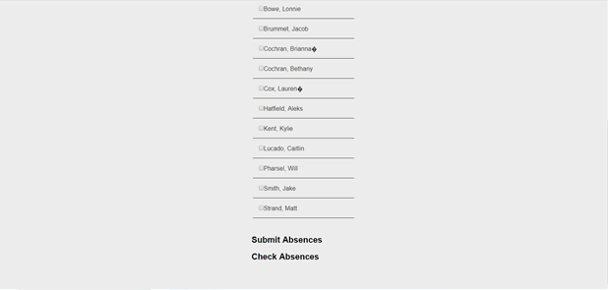

**3.3.4 Add Single Absence**

Single Absences can be added using the “Add Single Absence” button on the Attendance main page. When selecting this option, you will see a pop-up on your screen with places to enter the Student ID and the year/month/day of the absence. Enter the information and select “Add Absence.” You can also add a single absence by using the “Take Attendance” feature and only marking one student on the specified date.

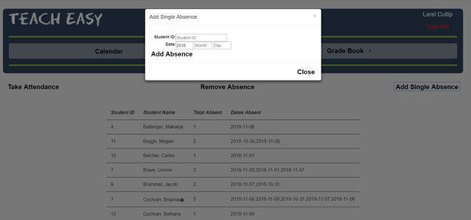

**3.3.5 Remove Absence**

To remove an absence, click the “Remove Absence” button on the “Attendance Page”. A modal will be brought up that prompts for an entry of the students ID number and the date which is to be removed. Enter these fields and then click “Remove Absence”. 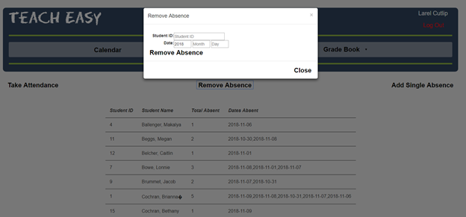

**3.4.1 Gradebook**

The gradebook displays the students for the user that is currently logged in and their grades for the selected subject’s assignments.

**3.4.2 Subjects**

Currently, there are only 4 subjects. English, Mathematics, Science, and Social Studies.

**3.4.3 Students**

The students are generated based on the teacher’s login. There is currently no way for the user to add or remove students. Please talk to your administrators for class roster changes.

**3.4.4 Grade Entry**

To add grades, click the button located below the header and above the table that lists the students and their grades. Once the modal appears with the students names, use the text box next to their names to enter the integer value of their grade. Click “Submit New Assignment” once the entries have been completed. All boxes must be filled (use a 0 for an assignment that has not been turned in).

